 | 65-inch Dual-System Infrared Touch Interactive Flat Panel  Product Specifications  Model: LYB65BSN

Product Overview

This 65-inch dual-system interactive flat panel combines a 4K UHD LED display with high-precision infrared touch technology. It runs Android 16.0 natively and supports an optional OPS PC module for dual-system Windows operation. Designed for smart classrooms, multimedia meeting rooms, lecture halls and training rooms, the panel supports multi-point writing, wireless screen mirroring and multi-source switching.
1. Product Rendering

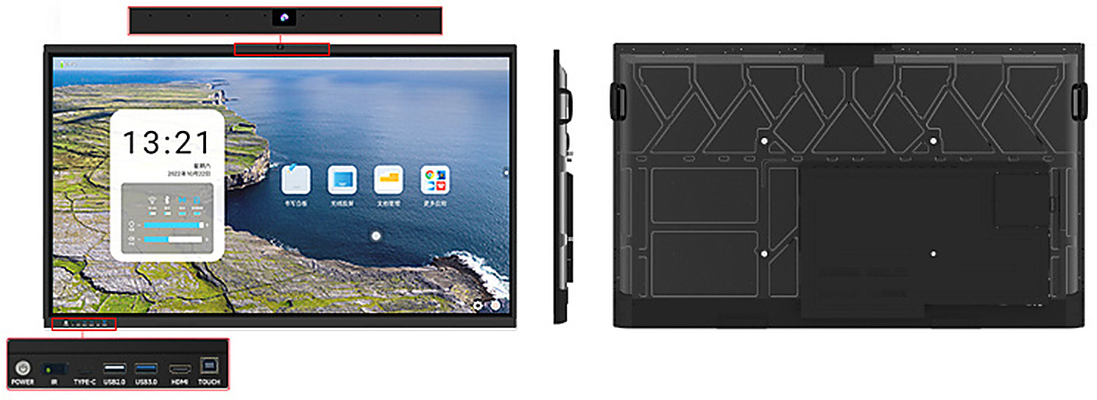
Product rendering (for reference only; the actual product may vary)
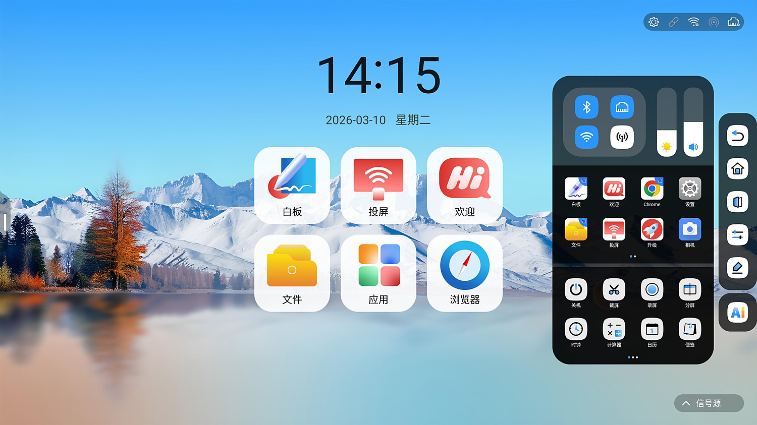 | 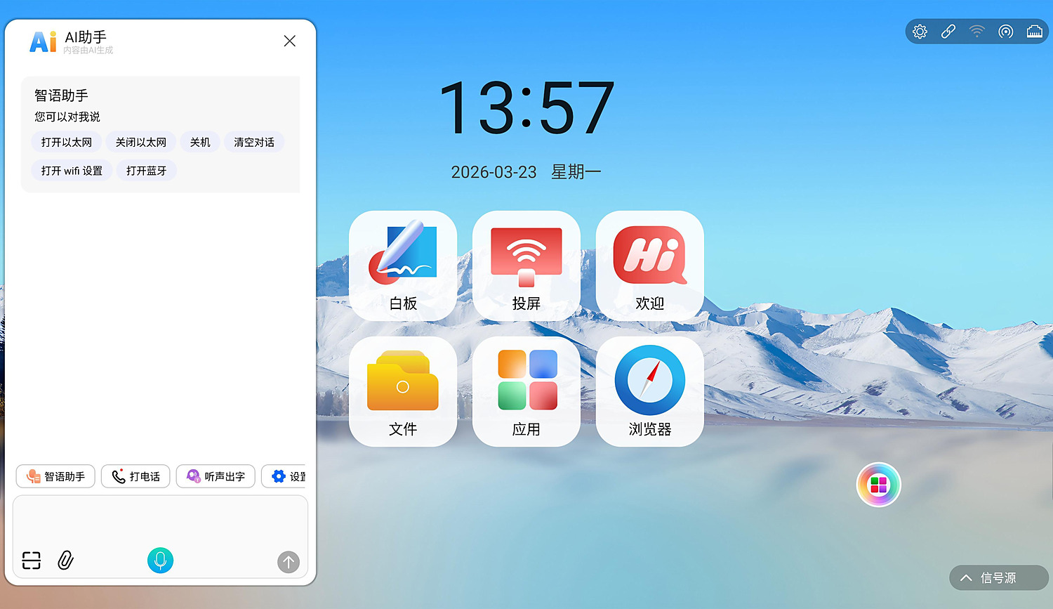
Main system interface | AI features
2. AI Features (Key Highlights)

AI Assistant  Voice assistant, phone calls, speech-to-text, QR-code commands from a phone and image analysis; voice-controlled smart subtitles and online lookup | AI Large Model + Formula Pen  Natural-language understanding with a 10,000+ command training set; handwritten formulas are recognised, then deleted or inserted into the whiteboard
AI Whiteboard Lasso  Recognises images and suggests search keywords; searches K-12 question banks by image; generates images from sketches or photos | Whiteboard OCR  Handwriting recognition in most languages, backed by a library of 10,000+ handwritten shape models
DMS Remote Control  Start a remote session from a web page and operate the panel in real time | Collaborative Whiteboard  Host and guest devices join one room with two-way sync of writing, erasing, lasso selection and chart insertion
Note: DMS remote control and the formula pen require a paid activation.

3. Design Highlights

Chassis
1. Aluminium alloy frame with sandblasted anodised finish and a steel rear cover, giving a strong metallic feel and active heat dissipation.
2. 4 mm fully tempered anti-shatter glass protects the LCD panel, improves visual quality and enhances the touch experience.
3. Low-friction structural design for a smooth, responsive writing feel.
4. Front-facing speakers prevent the sound degradation caused by recessed installation.
Interaction and Display
5. High-precision infrared touch frame: touch accuracy <1 mm, lift-off height <1 mm.
6. Supports simultaneous writing with two 2 mm pen tips or five 3 mm pen tips, and handwriting as small as 1 cm by several users at once.
7. 100% two-colour pen recognition (requires the Android whiteboard application).
8. No cursive joining when writing Latin script; meets the Promethean standard for UNESCO suppliers.
9. Gesture side menu for quick brightness, volume and input-source control; a side navigation bar calls up frequently used shortcuts.
10. Direct-lit (DLED) backlight module for stable, durable performance.
11. Freehand annotation over any Android or PC image, including live and full-screen annotation.
System and Expansion
12. Dual-system architecture: Android 16.0 built in, with an optional OPS PC module for Windows.
13. Standard international OPS slot with a one-piece plug-in design for easy upgrades and maintenance; no visible PC cabling on the outside.
14. The touch frame switches seamlessly between Android and Windows.
15. Multiple themes can be switched at any time, and the boot logo can be customised.
16. Built-in screen mirroring, electronic whiteboard and annotation functions.
17. Supports WiFi wireless and wired Ethernet connections.
18. Front expansion ports: 1x PC-USB, 1x full-channel USB, 1x HDMI input, 1x Type-C and 1x TOUCH USB for external devices.
19. Built-in 48 MP camera and an eight-microphone array.
4. Display Specifications

Screen Size | 65-inch LED panel (16:9), 1431.2 x 805.1 mm (H x V)
Panel Type | Brand-new ultra-high-definition LED panel
Resolution | 3840 (H) x 2160 (V)
Viewing Angle | 178° (H) / 178° (V)
Brightness | 400 cd/m²
Contrast Ratio | 5000:1
Response Time | 8 ms
Colour Depth | 16.7M
Scan Rate | 4K@30Hz
Backlight | DLED (direct-lit)
Display Output | HDMI
Colour System | PAL, NTSC
Audio Output | Three-dimensional stereo, 2 x 10 W output
Screen Protection | 4 mm fully tempered anti-shatter glass

5. Touch Specifications

Touch Integration | Built-in one-piece design, not externally mounted
Touch Technology | Infrared touch recognition (20-point)
Input Method | Finger, touch pen or any tip at least 2 mm in diameter
Cursor Speed | 120 points/s
Positioning Accuracy | ±1 mm over more than 90% of the touch area
Communication Port | USB Type-B male
Touch Resolution | 32767 x 32767
Touch Endurance | Unlimited in theory
Response Time | Auto-recognition by the system, <=15 ms
Driver | Driver-free
Touch Functions | 20-point PC touch operation, image zoom in/out and rotation
6. Unit Specifications

Operating System | Android 16.0 (optional OPS PC module for dual-system Windows operation)
Mounting | Wall bracket (standard)
Bracket Hole Spacing | 597 x 398 mm
Power Type | Three-core power cord / fixed
Power Connector | IEC C14 socket
Power Consumption | Approx. 253 W
Standby Power | <=0.5 W
Voltage Range | 110~240 V / 50~60 Hz
Speakers | 2 x 8 ohm 10 W front mid-range speakers
Recessed Mounting Dimensions | 1469.9 x 873.3 x 70.8 mm
Recessed Mounting Clearance | 20 mm on each side
Operating Environment | -10 °C to 55 °C; 10% RH to 90% RH
Storage Environment | -20 °C to 60 °C; 10% RH to 90% RH
Service Life | >=50,000 hours

7. Mainboard Solution: YS-EM3576

Mainboard Model | YS-EM3576 education display mainboard
SoC | Octa-core 64-bit, 4x Cortex-A72 + 4x Cortex-A53, up to 2.2 GHz
GPU | Mali-G52 MC3
NPU | 6 TOPS
Memory | 4 GB DDR4 (8 GB / 16 GB optional, expandable to 16 GB)
Storage | 32 GB (64 GB / 128 GB / 256 GB optional, expandable to 512 GB)
Video Decoding | 8K@30fps H.265 / H.264 / AVS3 / VVC / AV1 / HEVC
Video Encoding | 4K@30fps H.265 / H.264
Display Output | VBYONE 4K@60Hz x1; HDMI OUT 1080P x1; DP 4K@60Hz x1; VGA 4K@60Hz x1
Display Input | OPS 4K@60Hz x1; HDMI IN 4K@60Hz x1
Audio Interface | LINE IN x2; LINE OUT x1; SPDIF OUT (coaxial) x1; speaker output up to 4 x 8 ohm 15 W, 2.0/2.1 channel by default, 2.2 channel optional
Network | Gigabit adaptive Ethernet x2 (10/100/1000M); dual-band WiFi 6; Bluetooth 5.4; WiFi AP 2.4G/5G
USB | USB 2.0 x8; USB 3.0 x3; Type-B_OUT x2; Type-C_OTG x1 (65 W fast charging and DP1.4 display input)
Serial Ports | TTL x2; TTL-Debug x1; RS485 x1; DB9 RS232 x1
Expansion | IIC x1; GPIO x4; ADC KEY x8; IR x1; LED x1; TF card slot x1 (optional)
Front Panel Board | YS-MTEXT-V1: USB 2.0 Type-A x3, USB 2.0 TOUCH_OUT x1, USB 2.0 Type-C x1, HDMI IN x1 (4K@60Hz), light sensor x1, IR receiver x1, LED x2, power button x1
Board Dimensions | 230.0 x 245.0 x 18.0 mm, mounting holes Ø3.2 mm x6
Board Power | Normal 11.33 W; light sleep 10.30 W; standby 0.2 W
Mainboard specifications are compiled from the YS-EM3576 Product Approval Document V3.4 (Shenzhen Yisheng Technology Co., Ltd.). The actual shipping configuration may vary.
8. Optional OPS PC Configuration

Item | i5 configuration (optional) | i7 configuration (optional)
Processor | Intel Core i5 | Intel Core i7
Chipset | Intel chipset | Intel chipset
Memory / Storage | 8 GB DDR3 memory / 2.5-inch 256 GB drive | 8 GB DDR3 memory / 2.5-inch 256 GB drive
Graphics | Intel HD Graphics | Intel HD Graphics
Input Ports | 1x LAN, 3x USB 3.0, 3x USB 2.0, 1x MIC-IN
Output Ports | 1x HDMI, 1x VGA, 1x LINE-OUT
Operating System | Windows 10 / Windows 11 (optional; the actual version depends on the purchased configuration)

9. Standard Accessories

Standard accessories:
  Touch pen |   Warranty card |   Certificate of conformity
  User manual |   Remote control | 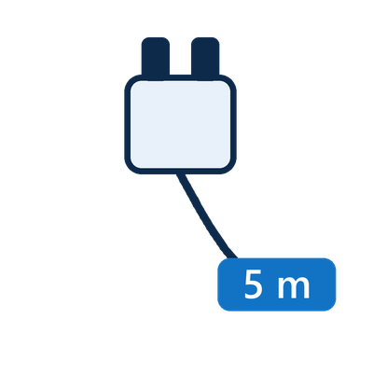  5 m power cord
10. Dimensions

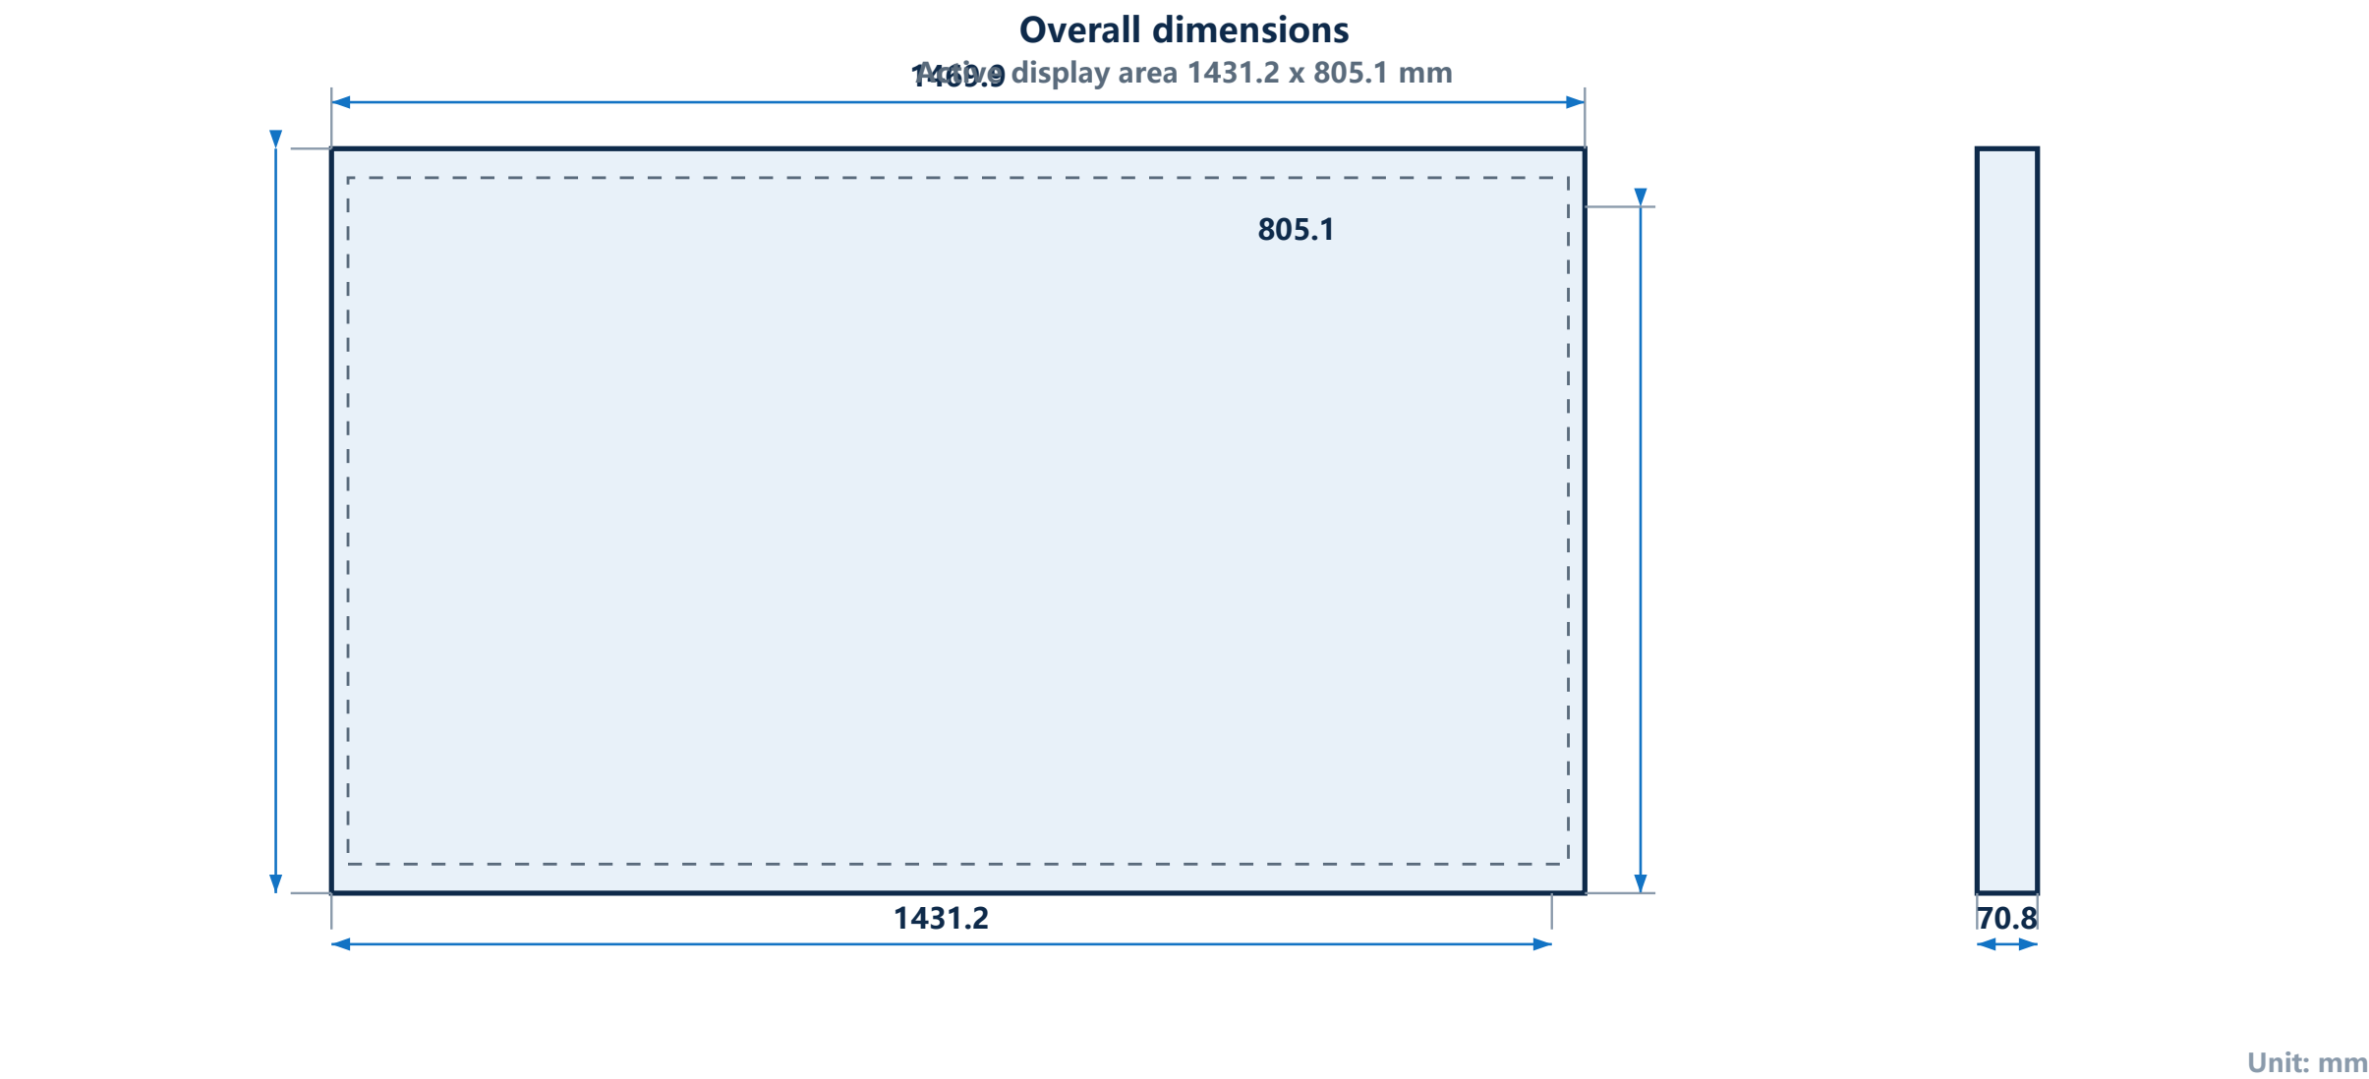
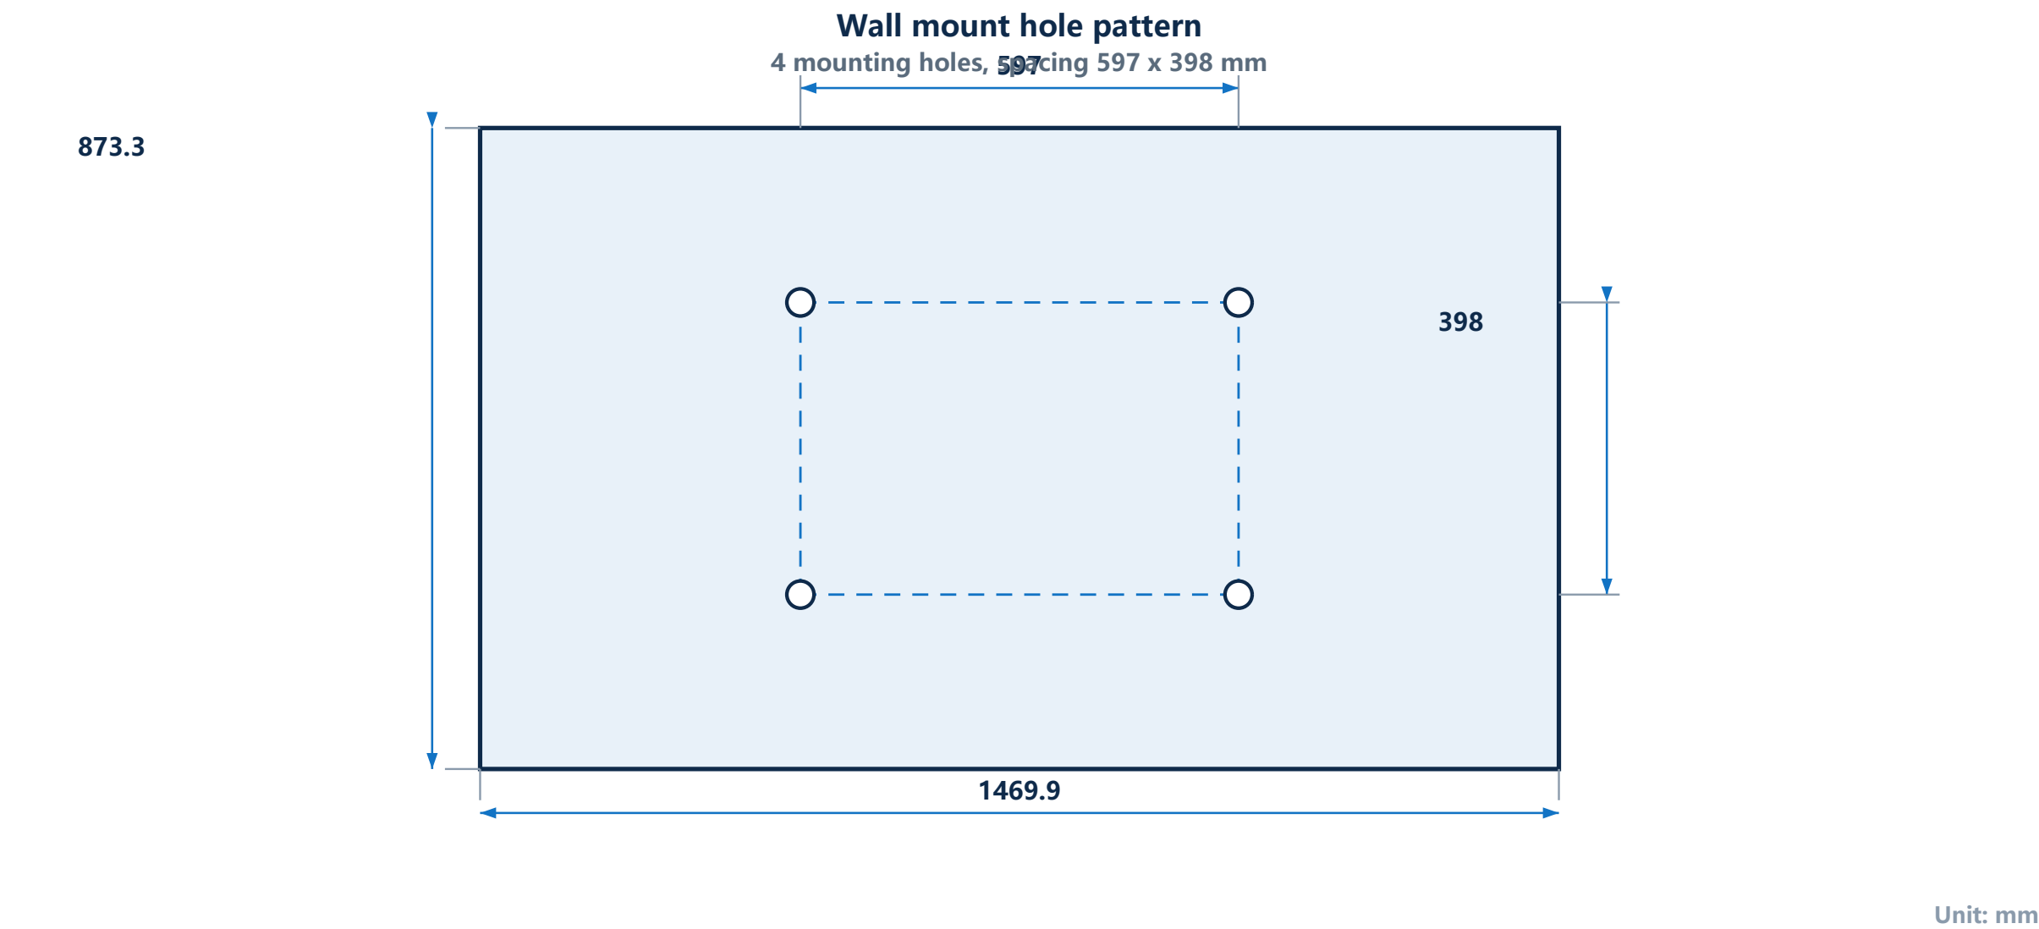

11. Typical Applications

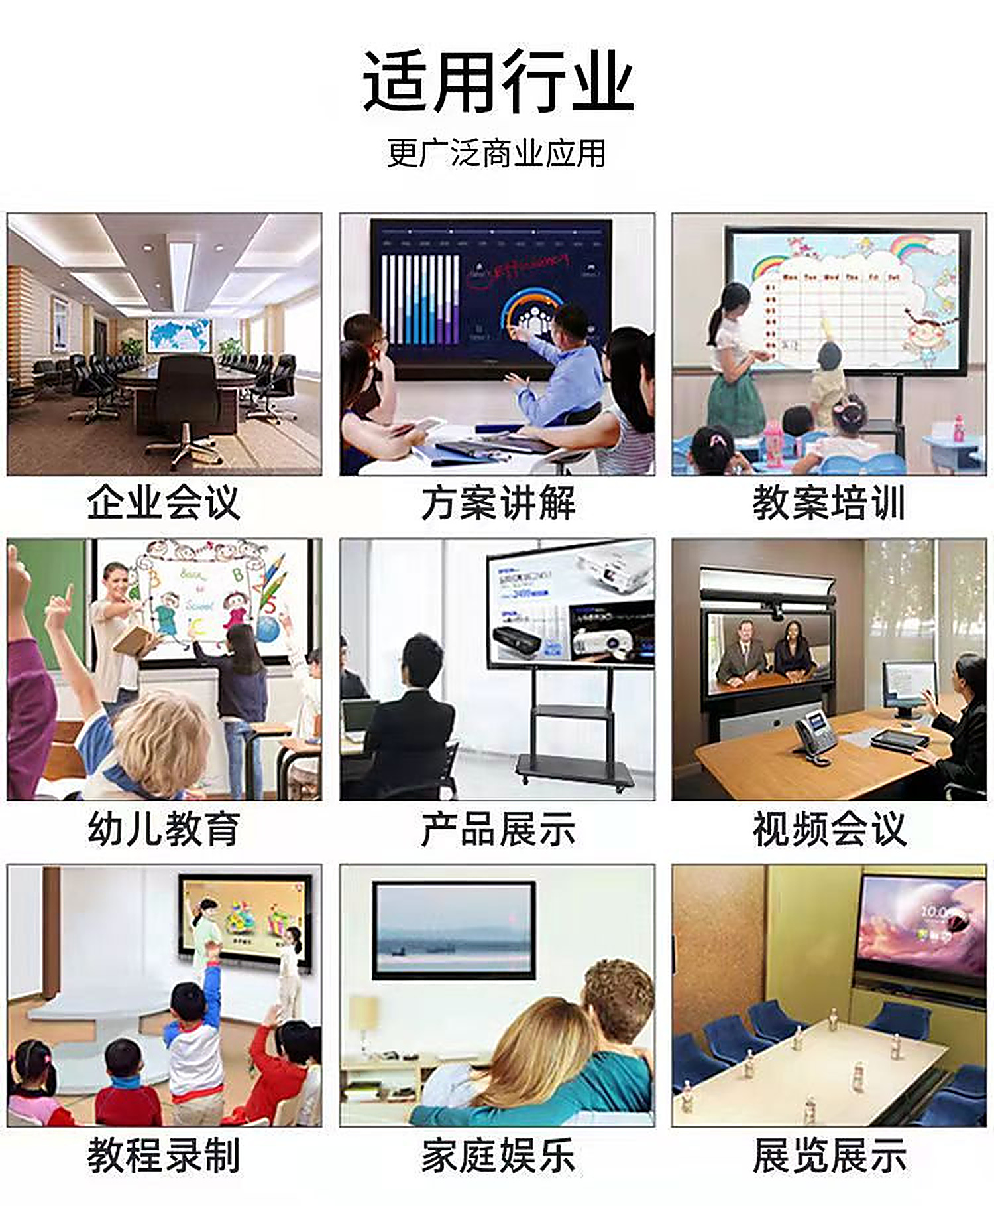
Typical applications: smart classrooms, multimedia meeting rooms, training rooms and lecture halls

